Testing your Mini Turbine:
Your mini turbine doesn’t produce enough electricity to light a bulb or run a motor (there are other TeacherGeek turbines that can). It will produce plenty of power for a standard multi-meter to measure.
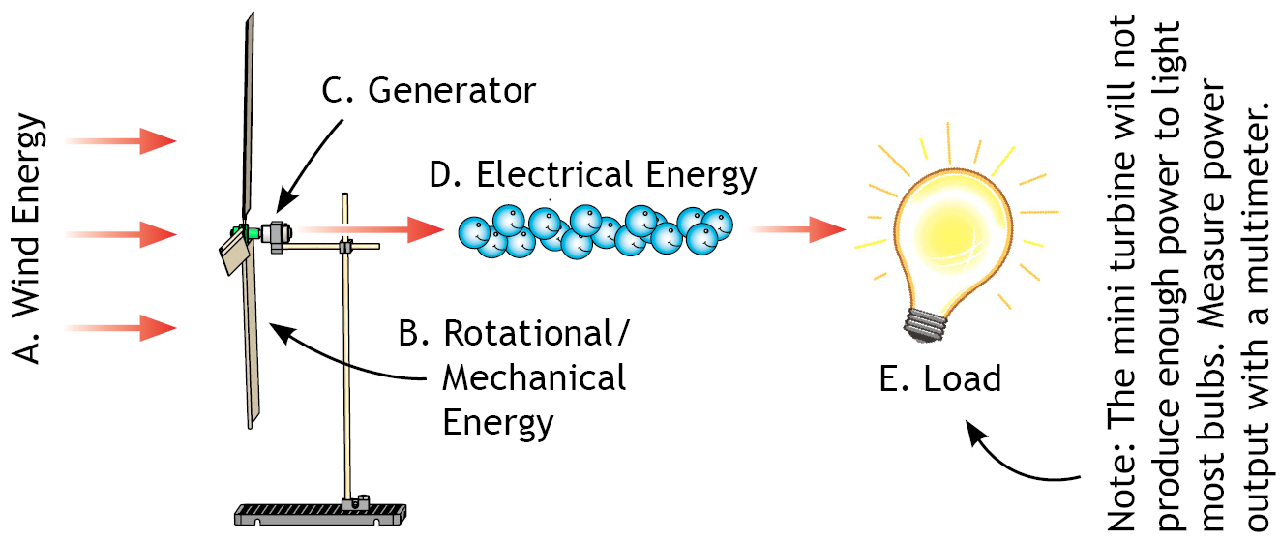
Testing Your Turbine - Without a Load:
Set your multi-meter to measure 0-2 volts. Connect leads from the multi-meter to the terminals on your mini turbine. The multi-meter should display a voltage output when the turbine rotor is turned. Note: Without a load, the readings on your multi-meter many not be stable. See how to test your turbine with a load on the next page.
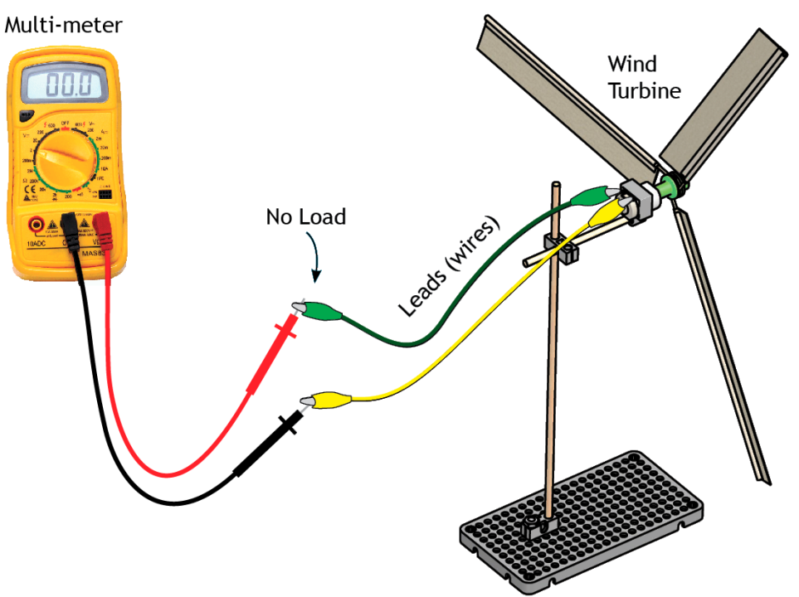
Load: A load is the part of an electrical circuit that “used the electricity.” The load converts the electrical energy into another form of energy.
Optional: Testing Your Turbine with a Load:
The proper way to test your turbine is to measure voltage across a load. Use a load if your meter measurements jump around while you are trying to read them. The load can be a bulb, resistor, small dc motor, or even a pencil with both ends sharpened. Note: the bulb and motor with not light up/run, but they will still use some electrical energy to heat up. The same load should be used throughout the lab.
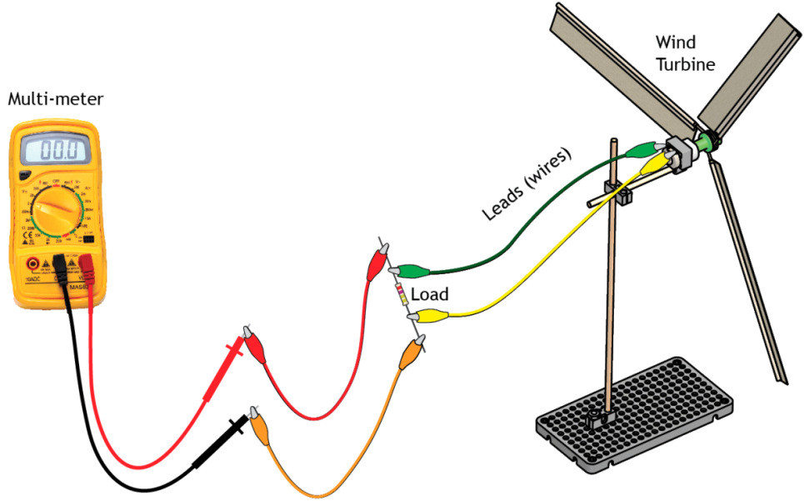

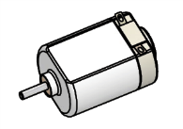
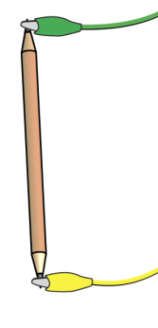
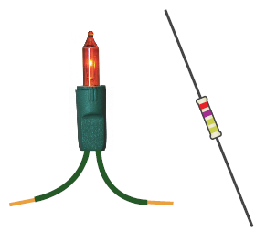
Loads:
Changing Blade Angles:
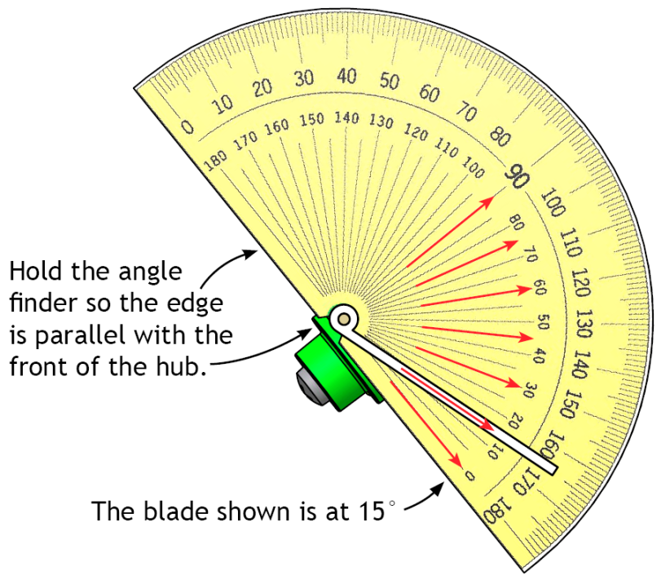
The angle of blades can easily be changed by slightly loosening the hub screw so the skewer sticks can rotate, but not fall out. The screw can be retightened after all blades are adjusted to the proper angle.

Measuring Blade Angles:
The TeacherGeek protractor is the best way to easily measure blade angles.
Here’s how you use it.
The red arrows show the most common angles used on mini wind turbines
(0°, 15°, 30°, 45°, 60°, 75°, 90°).

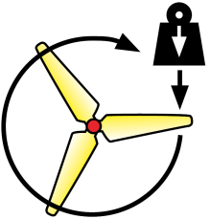
Torque: Torque is a twisting force. Some turbines use a gearbox to convert torque to additional RPM. Your mini turbine does not have a gearbox, so additional torque (more torque than it takes to spin the blades) will be lost.

Creating your own wind turbine design:
You can change the:
- Blade angle
- diameter of blades
- number of blades
- shape of blades
- mass of blades

