Name: ___________________________________________ Set: _________ Date: _________

This guide will take you through the process of creating a basic electric racer. After you finish this build, you should be able to experiment, design and engineer your own racer.

**Materials included in TeacherGeek Racer Packs:**

Component colors may be different then shown.

|  |  |  |  |  |  |
| --- | --- | --- | --- | --- | --- |
| **Component** | **Picture** | **# in 10 Pack** | **# For a Single Racer** | **# Required to Build Example Racer** | **# Extra -To Innovate Your Own Design** |
| **Strips** |  | 40 | **4** | 0 | 4 |
| **Dowels** |  | 80 | **8** | 4 | 4 |
| **Blocks** |  | 40 | **4** | 2 | 2 |
| **Hole Plates** |  | 20 | **2** | 2 | 0 |
| **Slide Stop 30cm** |  | 3 | **7.5cm (3in)** | 1.5cm | 6cm |
| **#10**  **Screws** |  | 80 | **8** | 3 | 5 |
| **#10 Nuts** |  | 80 | **8** | 3 | 5 |
| **Rubber Bands** |  | ~100 | **~10** | 1 | ~9 |
| **70mm Pulleys** |  | 10 | **1** | 1 | 0 |
| **55.5mm Pulleys** |  | 10 | **1** | 0 | 1 |
| **25.5mm Pulleys** |  | 10 | **1** | 0 | 1 |
| **9mm Pulleys** |  | 10 | **1** | 1 | 0 |
| **50 Tooth Gears** |  | 10 | **1** | 1 | 0 |
| **Component** | **Picture** | **# in 10 Pack** | **# For a Single Racer** | **# Required to Build Example Racer** | **# Extra -To Innovate Your Own Design** |
| **40 Tooth Gears** |  | 10 | **1** | 0 | 1 |
| **20 Tooth Gears** |  | 10 | **1** | 0 | 1 |
| **10 Tooth Gears** |  | 10 | **1** | 1 | 0 |
| **Wheels** |  | 40 | **40** | 0 | 0 |
| **Rubber Band Tires** |  | 40 | **4** | 2 | 2 |
| **Battery Holders** |  | 10 | **1** | 1 | 0 |
| **Project Motors** |  | 10 | **1** | 1 | 0 |
| **Angle Brackets** |  | 20 | **2** | 0 | 0 |
| **Motor Mounts** |  | 10 | **1** | 1 | 0 |
| **Stop Clips** |  | 40 | **4** | 1 | 3 |
| **Motor Adaptor Pins** |  | 15 | **1** | 1 | 0 |

**Other Materials:**

**Two AA batteries are required per racer, but not included in the kit.**

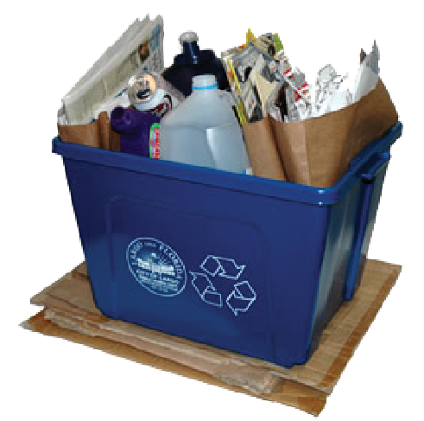

The TeacherGeek system is designed to be used with other materials you can find (materials not supplied in the TeacherGeek pack). Other materials could be craft supplies, from a recycling bin, wood, metal, cardboard, or anything else you may have. These materials can be used to help you create your own unique designs.

**Tools Required:**

|  |  |  |  |  |  |
| --- | --- | --- | --- | --- | --- |
| **Tool** | **Picture** | **Use** | **# Required** | **# Suggested for Classes** | **Alternate** |
| **Reamer** |  | Enlarge holes so dowels slide & rotate | 1 | 1 for every 3-4 students | Drill bit and drill |
| **Multi-Cutter** |  | Cut wood, plastic, cardboard | 1 | 1 for every 3-4 students | Side Cutters, Saw, Pruning Shears |
| **Pliers** |  | Tighten nuts, pull out dowels | 1 -Optional | 1 for every 3-4 students | Wrench |
| **Phillips Screwdriver** |  | Tighten screws | 1 | 1 for every 3-4 students |  |
| **Crayon or Wax** |  | Rub on dowel to make it slide easier into a hole | 1 -Optional | 1 for every 3-4 students | Wax |
| **Safety Glasses** |  | Protect eyes | 1 | 1 per student |  |

Age Level Recommendation: 12 and above

Wear safety glasses when building and testing your racer.

**Construction:**

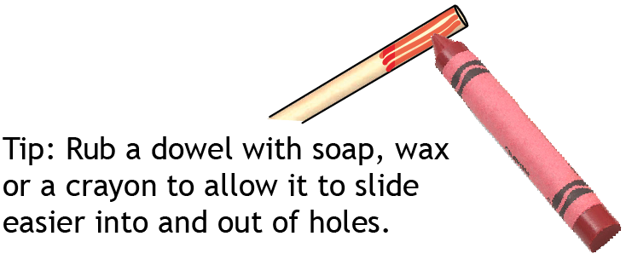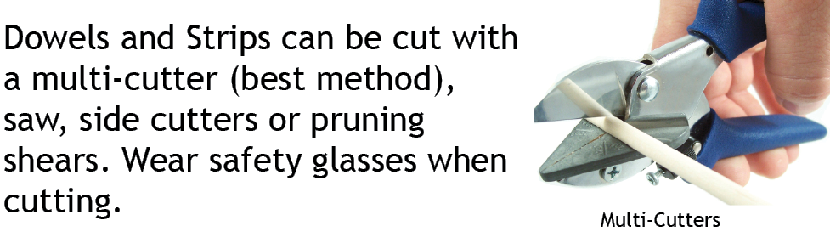

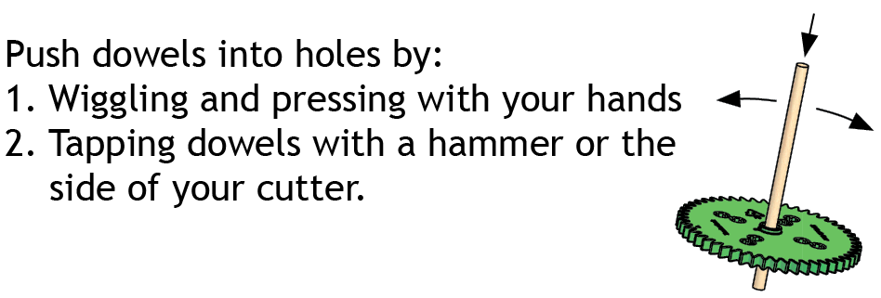

**Step #1**

Cut four 12cm (4 in) dowels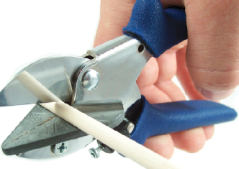.

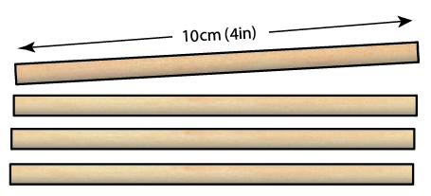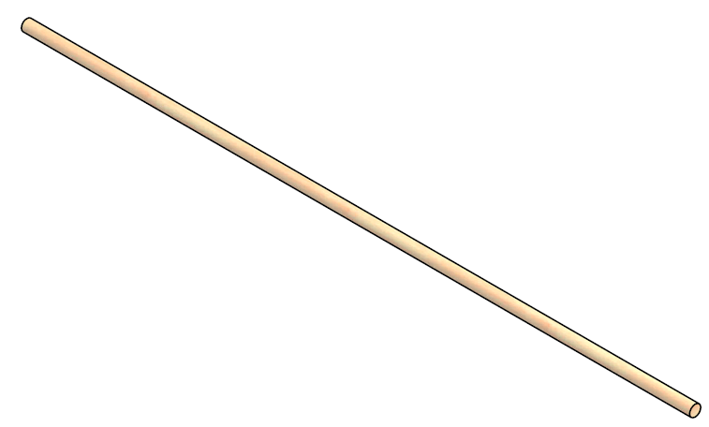

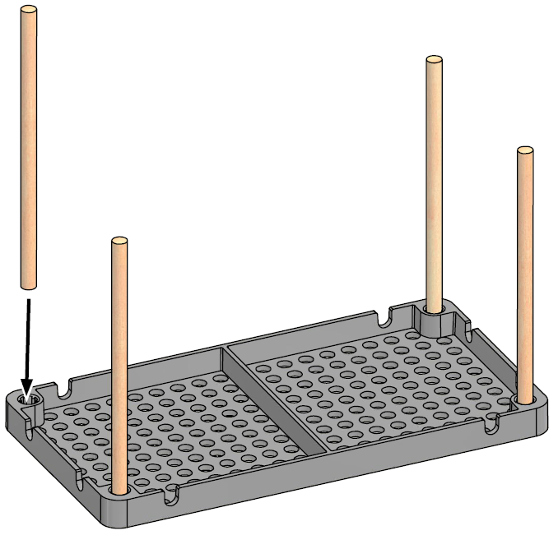

**Step #2**

Press/tap the 12cm (4in) dowels into a hole plate.

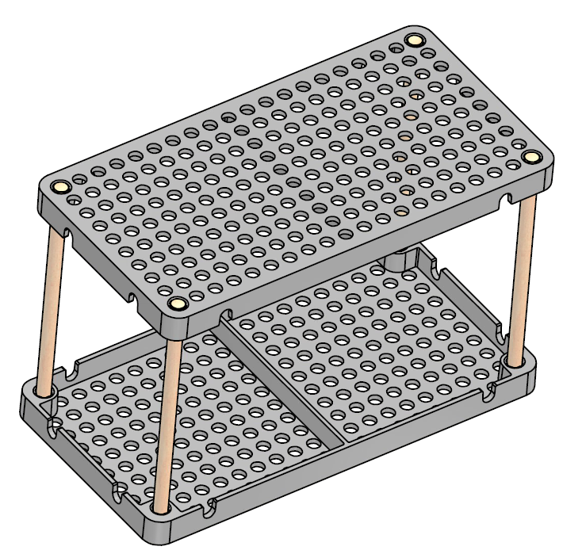

**Step #3**

Push/tap a second hole plate onto the dowels. This creates the frame for your racer.

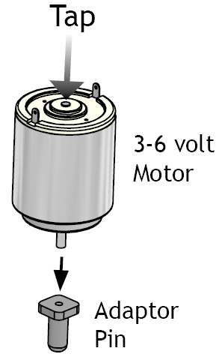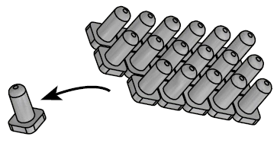

**Step #4**

Cut off an adaptor pin.

**Step #5**

Tap or push the motor shaft into the adaptor pin. Warning: Only push/tap on the back of the motor shaft. Pushing from the sides of

the motor could cause the motor to fall apart.

Tip: Place the adaptor pin into a perpendicular block

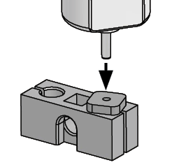to hold it while tapping the motor shaft in.

**Step #6**

Place the motor into a mount.

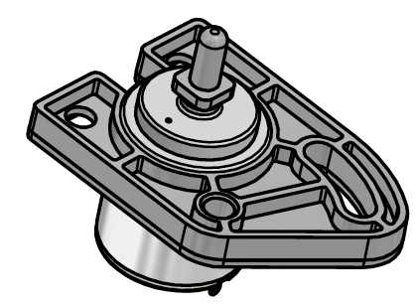

**Step #7**

Use a screw and nut to fasten the motor mount to the frame.

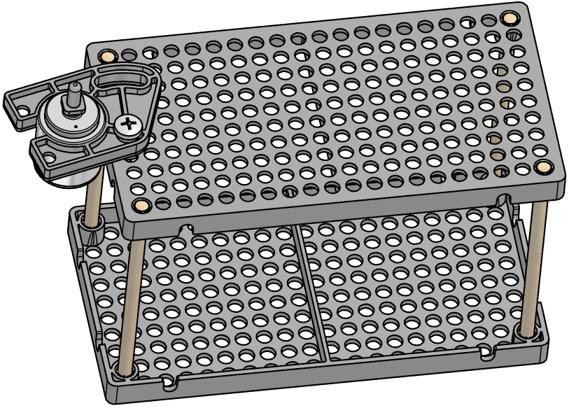 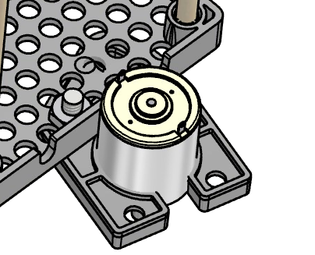

**Step #8**

Cut V shaped notches on the battery holder tabs.

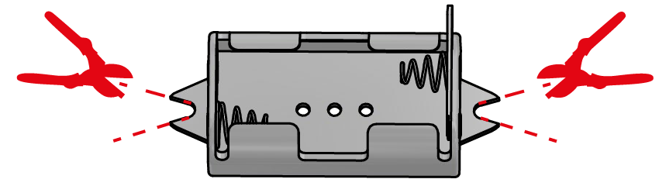

**Step #9**

Use two screws and nuts to attach the battery holder to the frame.

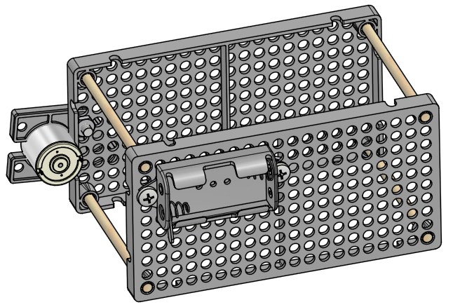 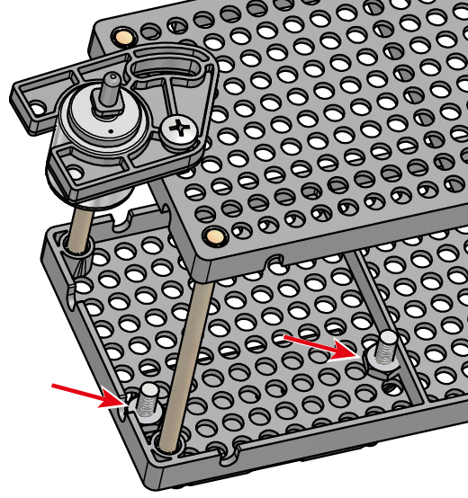

**Step #10**

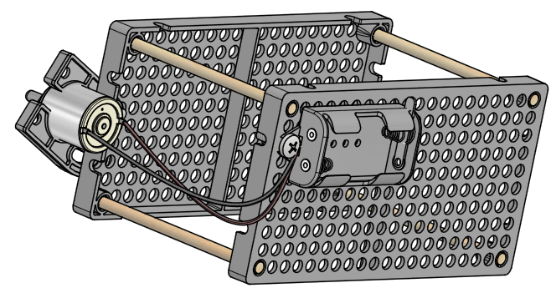Connect the wires from the battery holder to the motor terminals. Twist the stripped wires around the motor terminals to help them stay on.

Tip: Strip more insulation off the wire ends. Use the additional exposed wire to twist around after feeding through the motor terminal.

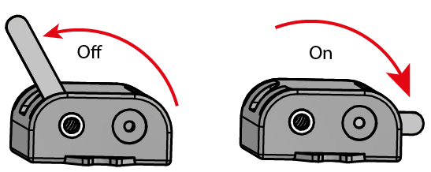**Run the motor**

Place two AA batteries into the battery holder. Use the lever switch on the battery holder to turn the motor on and off. If the motor does not run, check the wires connected to the motor terminals. Make sure that the metal wires are touching the metal terminals.

Reversing Polarity: What happens if you switch the wires

on the motor terminals?

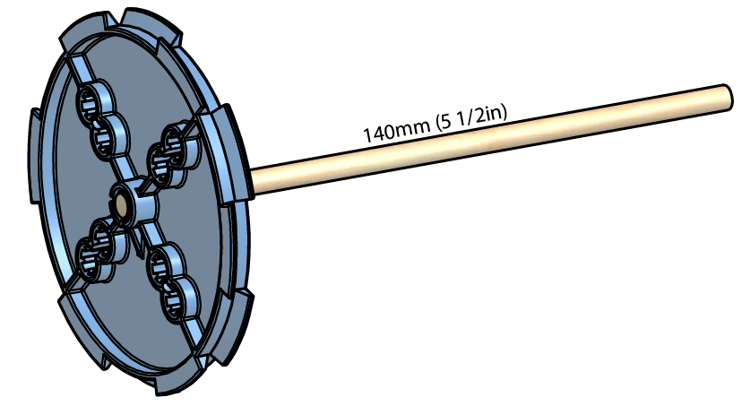

**Step #11**

Cut a 140mm (5 1/2in) dowel and tap it into the largest pulley. The colors of your pulleys may be different than pictured.

**Step #12**

Cut a 15mm (5/8in) section of slide stop. Slide it down the dowel, next to the pulley.

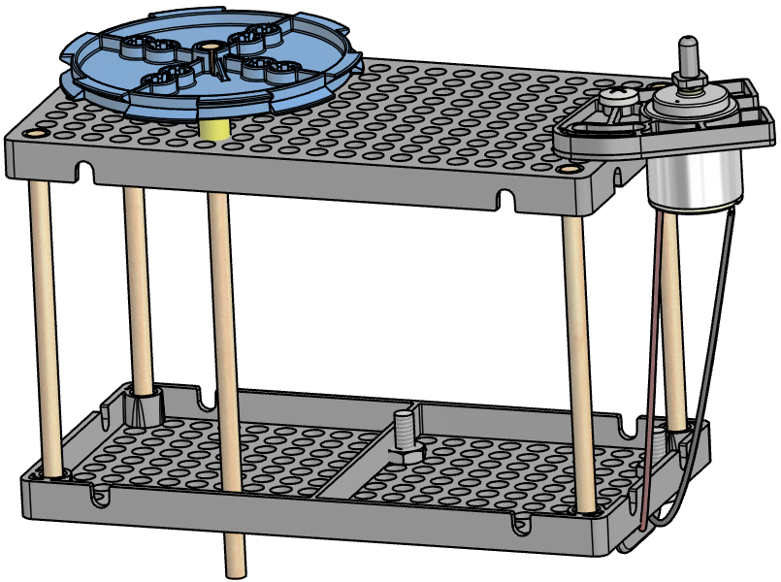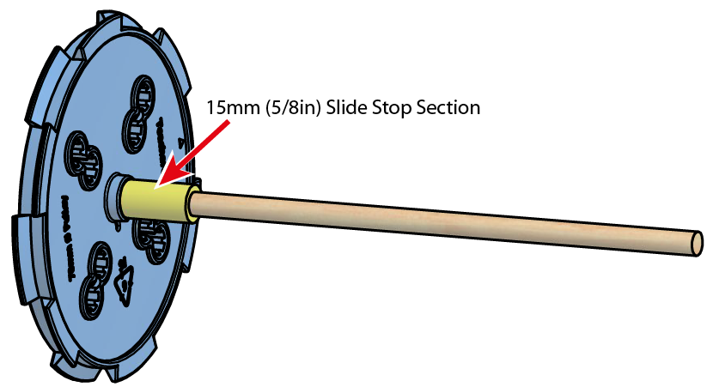

**Step #13**

Place the assembly from Step #12 into the frame holes shown.

**Step #14**

Place a small pulley onto the motor pin. Your small pulley may be a different color.

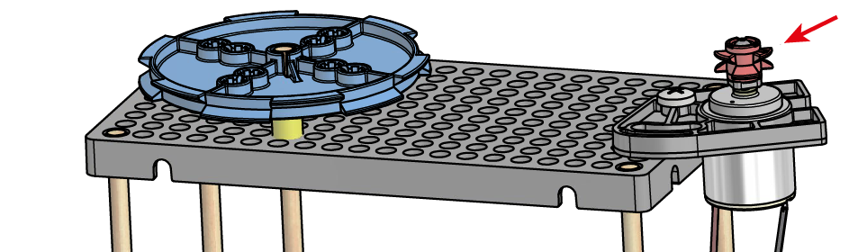

**Step #15**

Wrap a small rubber band around the pulleys.

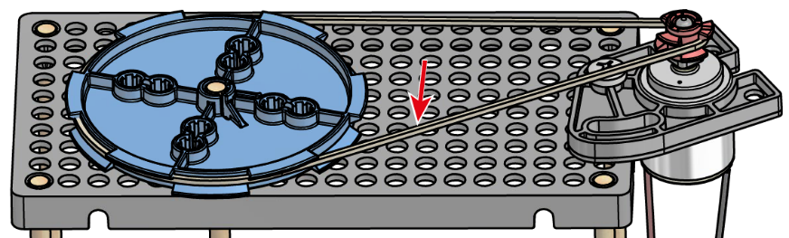

**Pulleys & Mechanical Advantage**

Place a mark (with a pencil or pen) on the face of your pulleys. Rotate one of the pulleys all the way around. How far did the other pulley turn? Switch the pulleys around. Exchange them for a different size. Rotate them again. What happens? Pulleys can trade force for distance, or distance for force:

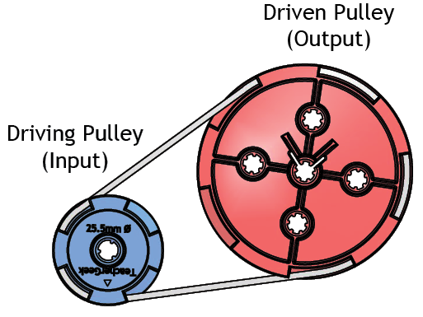 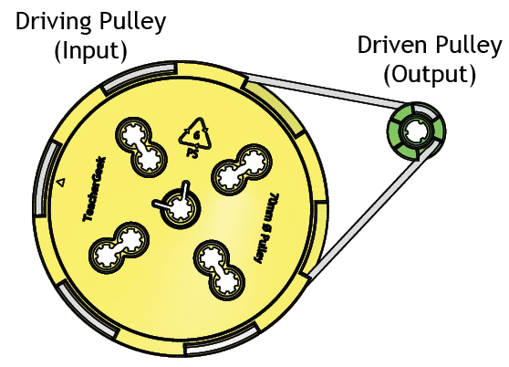

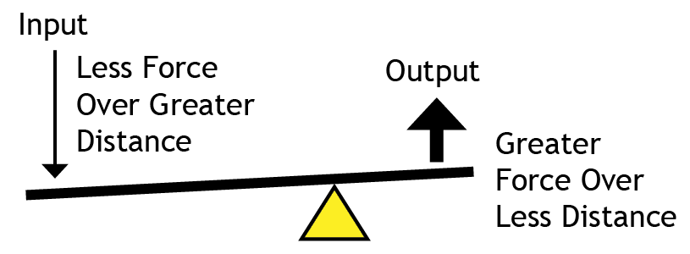 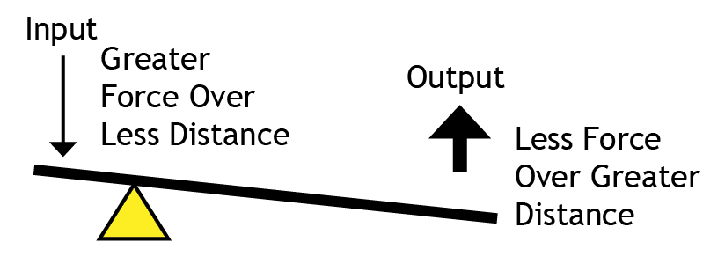

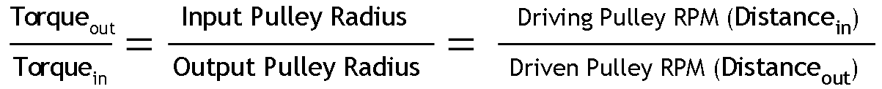

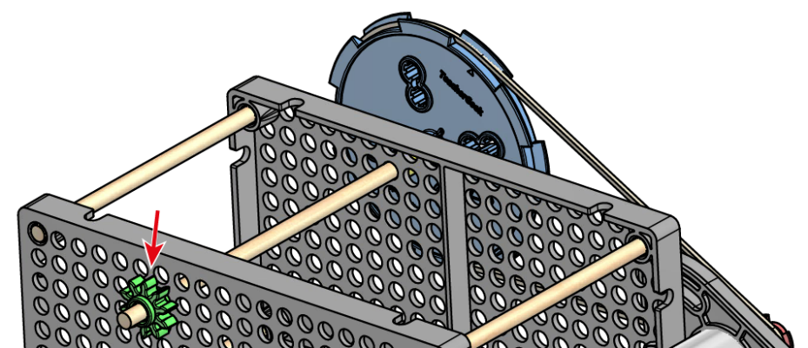**Step #16**

Place the smallest gear onto the pulley dowel.

**Step #17**

Cut a 200mm (7 7/8in) dowel. Tap the dowel through a large, 50 tooth gear, so it sticks out 40mm (1 9/16in)

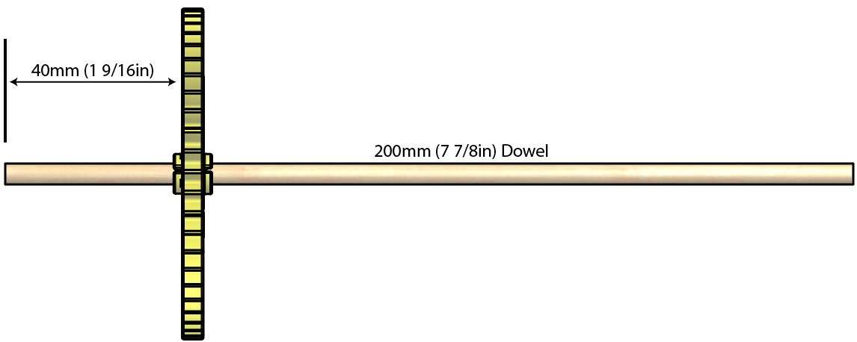

**Step #18**

Place the assembly from Step #17 into the frame, so the small and large gears mesh.

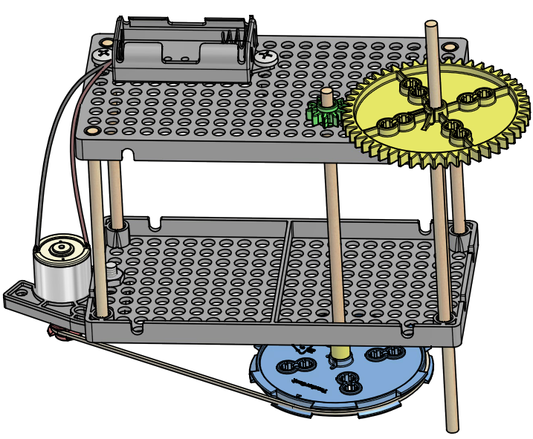 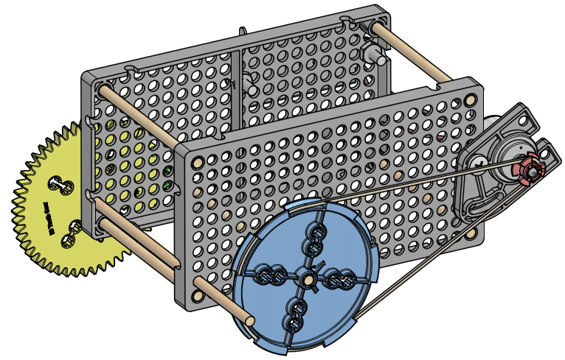

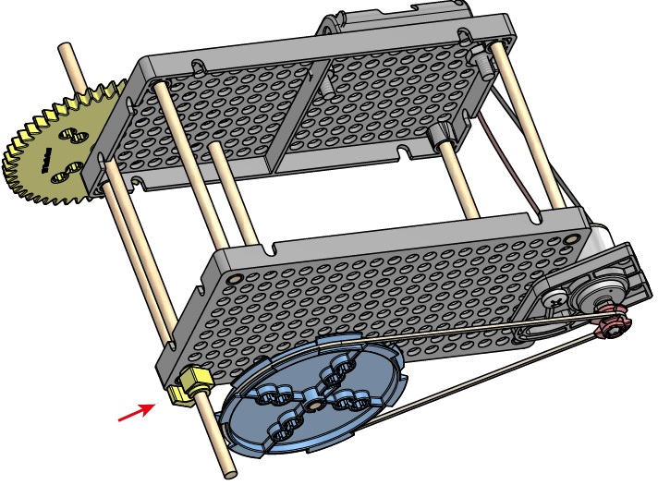**Step #19**

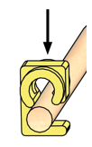Use a stop clip (pictured), or a section of slide stop to keep the dowel with the large gear from sliding out.

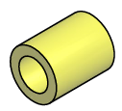

or

**Gears & Mechanical Advantage**

You may want to change your gears and pulleys on your racer to make it faster or stronger. In that case, you need to know that gears work much like pulleys; trading force for distance or distance for force.

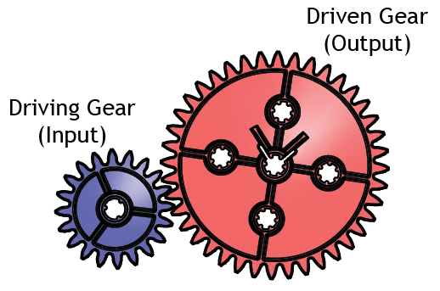 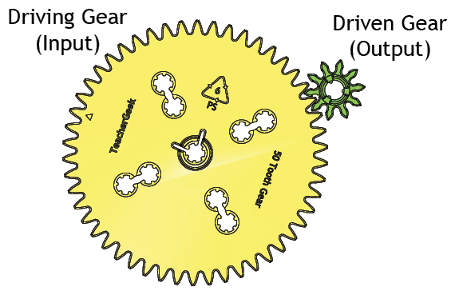

  

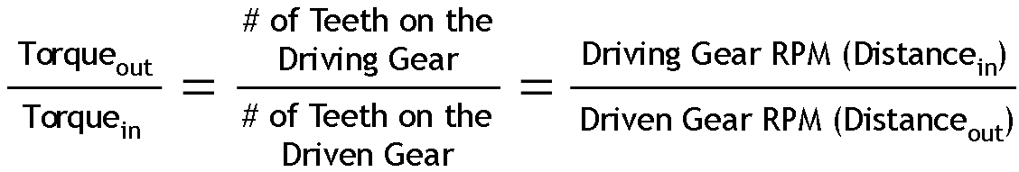

**Step #20**

Push/tap two wheels onto the ends of the dowel.

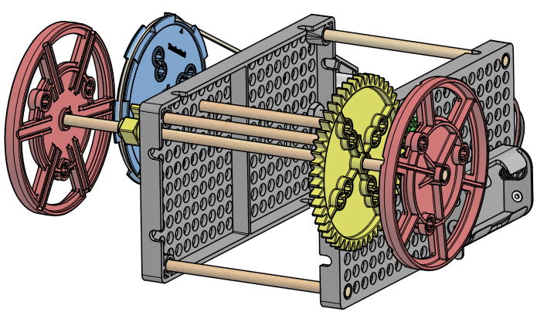

**Step #21**

Cut a new 200mm (7 7/8in) dowel. Then cut two sections of slide stop. Use the slide stop, 200mm dowel and two wheels to make your racer roll.

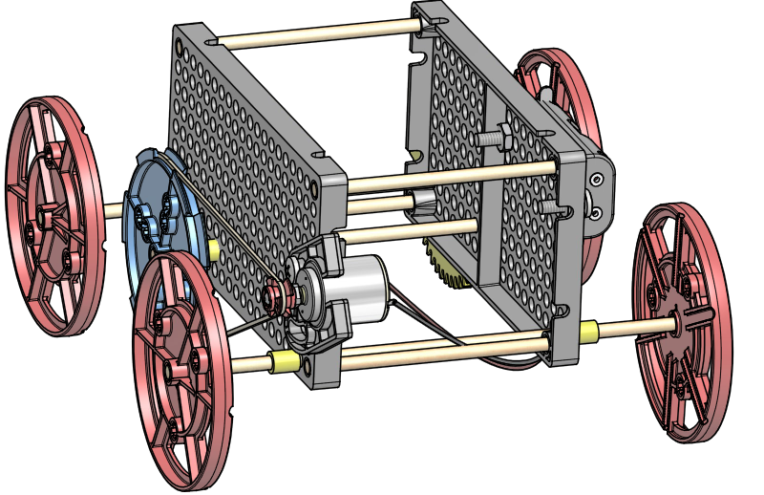

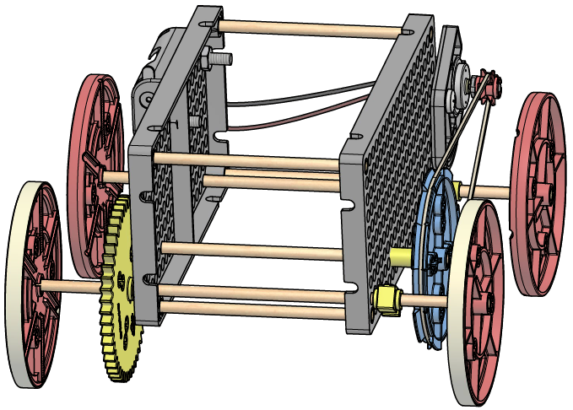**Step #22**

Give your racer traction by wrapping large rubber bands around the wheels.

**Your example racer is done. It’s ok, but you can make it much better…**

It is now time for you to re-engineer and evolve your racer. Extra components have been included to help you do this.

Ideas:

•Create a New Frame/Layout

•Develop Better Power Transfer (change the pulleys and gears)

•Add components (wood, metal, stuff from a recycling bin)

•Give it Personality

•Add a Solar Panel

**Compound Gears and Pulleys**

Multiple gears and pulleys can be linked to create a greater mechanical advantage. Experiment by changing the gears and pulleys on your racer.

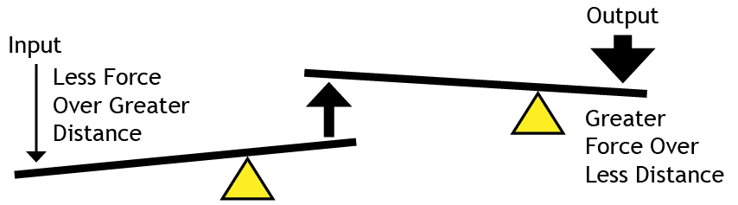

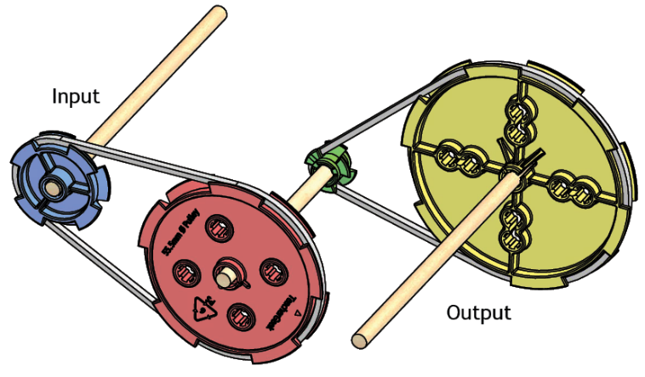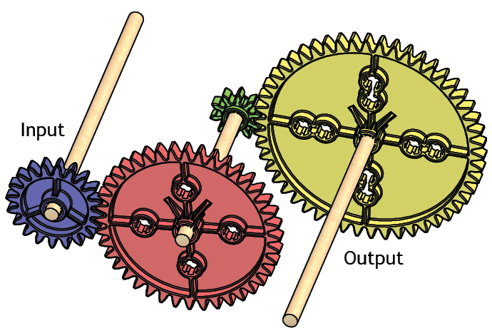

**Extreme Challenges**

Re-engineer your electric racer to compete in extreme challenges. Build it for one competition, then re-engineer it for another.

