Design and Engineer your own sail car.   
Test how well it’s powered by the wind!

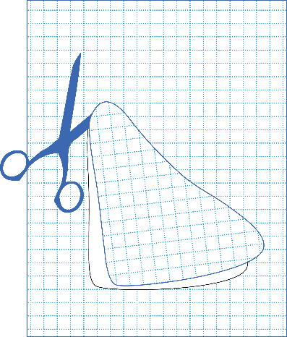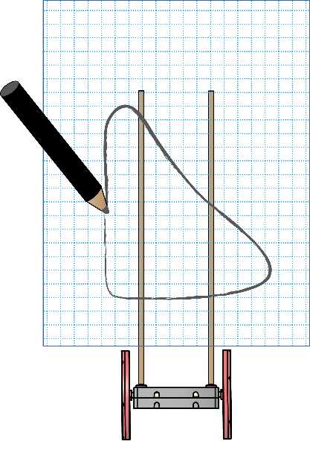Example Challenge Process:

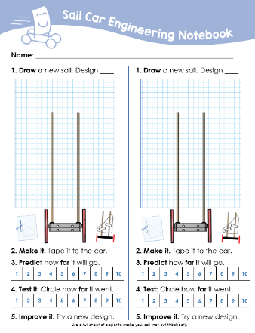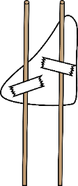





**Circle your answers**

**Predict** how **far** it will go.



**Design A**



?

|  |  |  |  |  |  |  |  |  |  |  |
| --- | --- | --- | --- | --- | --- | --- | --- | --- | --- | --- |
|  | **1** | **2** | **3** | **4** | **5** | **6** | **7** | **8** | **9** | **10** |

**Test it.** Circle how **far** it went.

?

|  |  |  |  |  |  |  |  |  |  |  |
| --- | --- | --- | --- | --- | --- | --- | --- | --- | --- | --- |
|  | **1** | **2** | **3** | **4** | **5** | **6** | **7** | **8** | **9** | **10** |



Download Documents at[**teachergeek.com/learn**](https://teachergeek.com/learn)



Design and Engineer a sail to go the distance   
or speed down a track. There is no one solution and every design can always be improved.

<http://www.demco.com/goto?teachergeek_ins&intcmp=TG_Instructions>

**Track Setup**

* Find floor space for at least one Sail Car Track. It should be at least 1m by 3m (3ft by 12ft). It’s best if the floor for the track is not carpeted.
* Place a desk fan where the track will start.
* Write “START” on a 30cm (12in) section of tape. Place the tape about 30cm (12in) in front of the fan.
* Use labeled sections of tape to mark out every 30cm (12in) in front of the starting line. Label the tape markers, in front of the starting line, from 1 to 10.

Design and draw your own sail shapes using the following Engineering Notebook pages. Draw your sail concept, make a prediction, draw your design on the full-sized graph paper, cut it out and tape to your Sail Car. Then, test and improve your design.

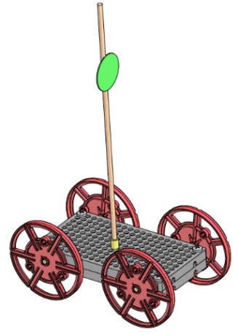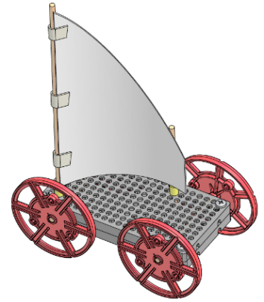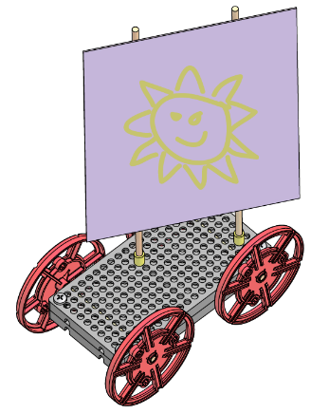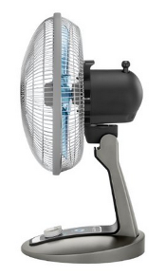

For use with TeacherGeek Sail Car Activity.

**Name: _________________________________________________________**

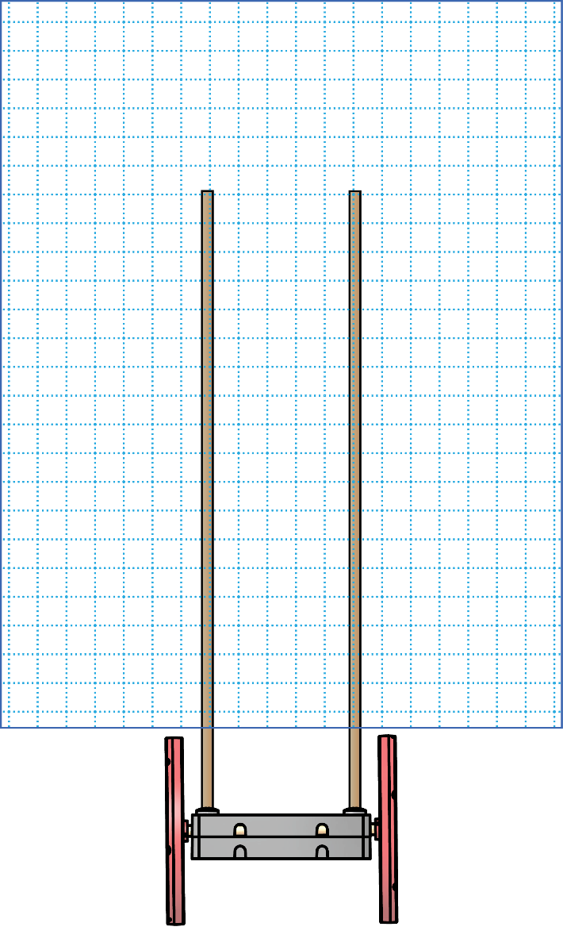**1. Draw** a new sail. Design ____ **1. Draw** a new sail. Design ____

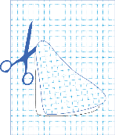****



**2. Make it.** Tape it to the car. **2. Make it.** Tape it to the car.

**3. Predict** how **far** it will go. **3. Predict** how **far** it will go.

|  |  |  |  |  |  |  |  |  |  |
| --- | --- | --- | --- | --- | --- | --- | --- | --- | --- |
| **1** | **2** | **3** | **4** | **5** | **6** | **7** | **8** | **9** | **10** |

|  |  |  |  |  |  |  |  |  |  |
| --- | --- | --- | --- | --- | --- | --- | --- | --- | --- |
| **1** | **2** | **3** | **4** | **5** | **6** | **7** | **8** | **9** | **10** |

**4. Test it.** Circle how **far** it went. **4.** **Test:** Circle how **far** it went.

|  |  |  |  |  |  |  |  |  |  |
| --- | --- | --- | --- | --- | --- | --- | --- | --- | --- |
| **1** | **2** | **3** | **4** | **5** | **6** | **7** | **8** | **9** | **10** |

|  |  |  |  |  |  |  |  |  |  |
| --- | --- | --- | --- | --- | --- | --- | --- | --- | --- |
| **1** | **2** | **3** | **4** | **5** | **6** | **7** | **8** | **9** | **10** |

**5. Improve it.** Try a new design. **5. Improve it.** Try a new design.

Use a full sheet of paper to make your sail (do not cut this sheet).

**Name: _________________________________________________________**

**1. Draw** a new sail. Design ____ **1. Draw** a new sail. Design ____





**2. Make it.** Tape it to the car. **2. Make it.** Tape it to the car.

**3. Predict** how **fast** it will go. **3. Predict** how **fast** it will go.



**4. Test it.** Circle how **fast** it went. **4.** **Test:** Circle how **fast** it went.



**5. Improve it.** Try a new design. **5. Improve it.** Try a new design.

Use a full sheet of paper to make your sail (do not cut this sheet).

Make your sail out of this paper.



Make your sail from this paper.



Make your sail from this paper.