Wind is an *AMAZING* energy source!  
Harness the power of wind.

**CLASSROOM COPY***Save Paper, Share in Groups*

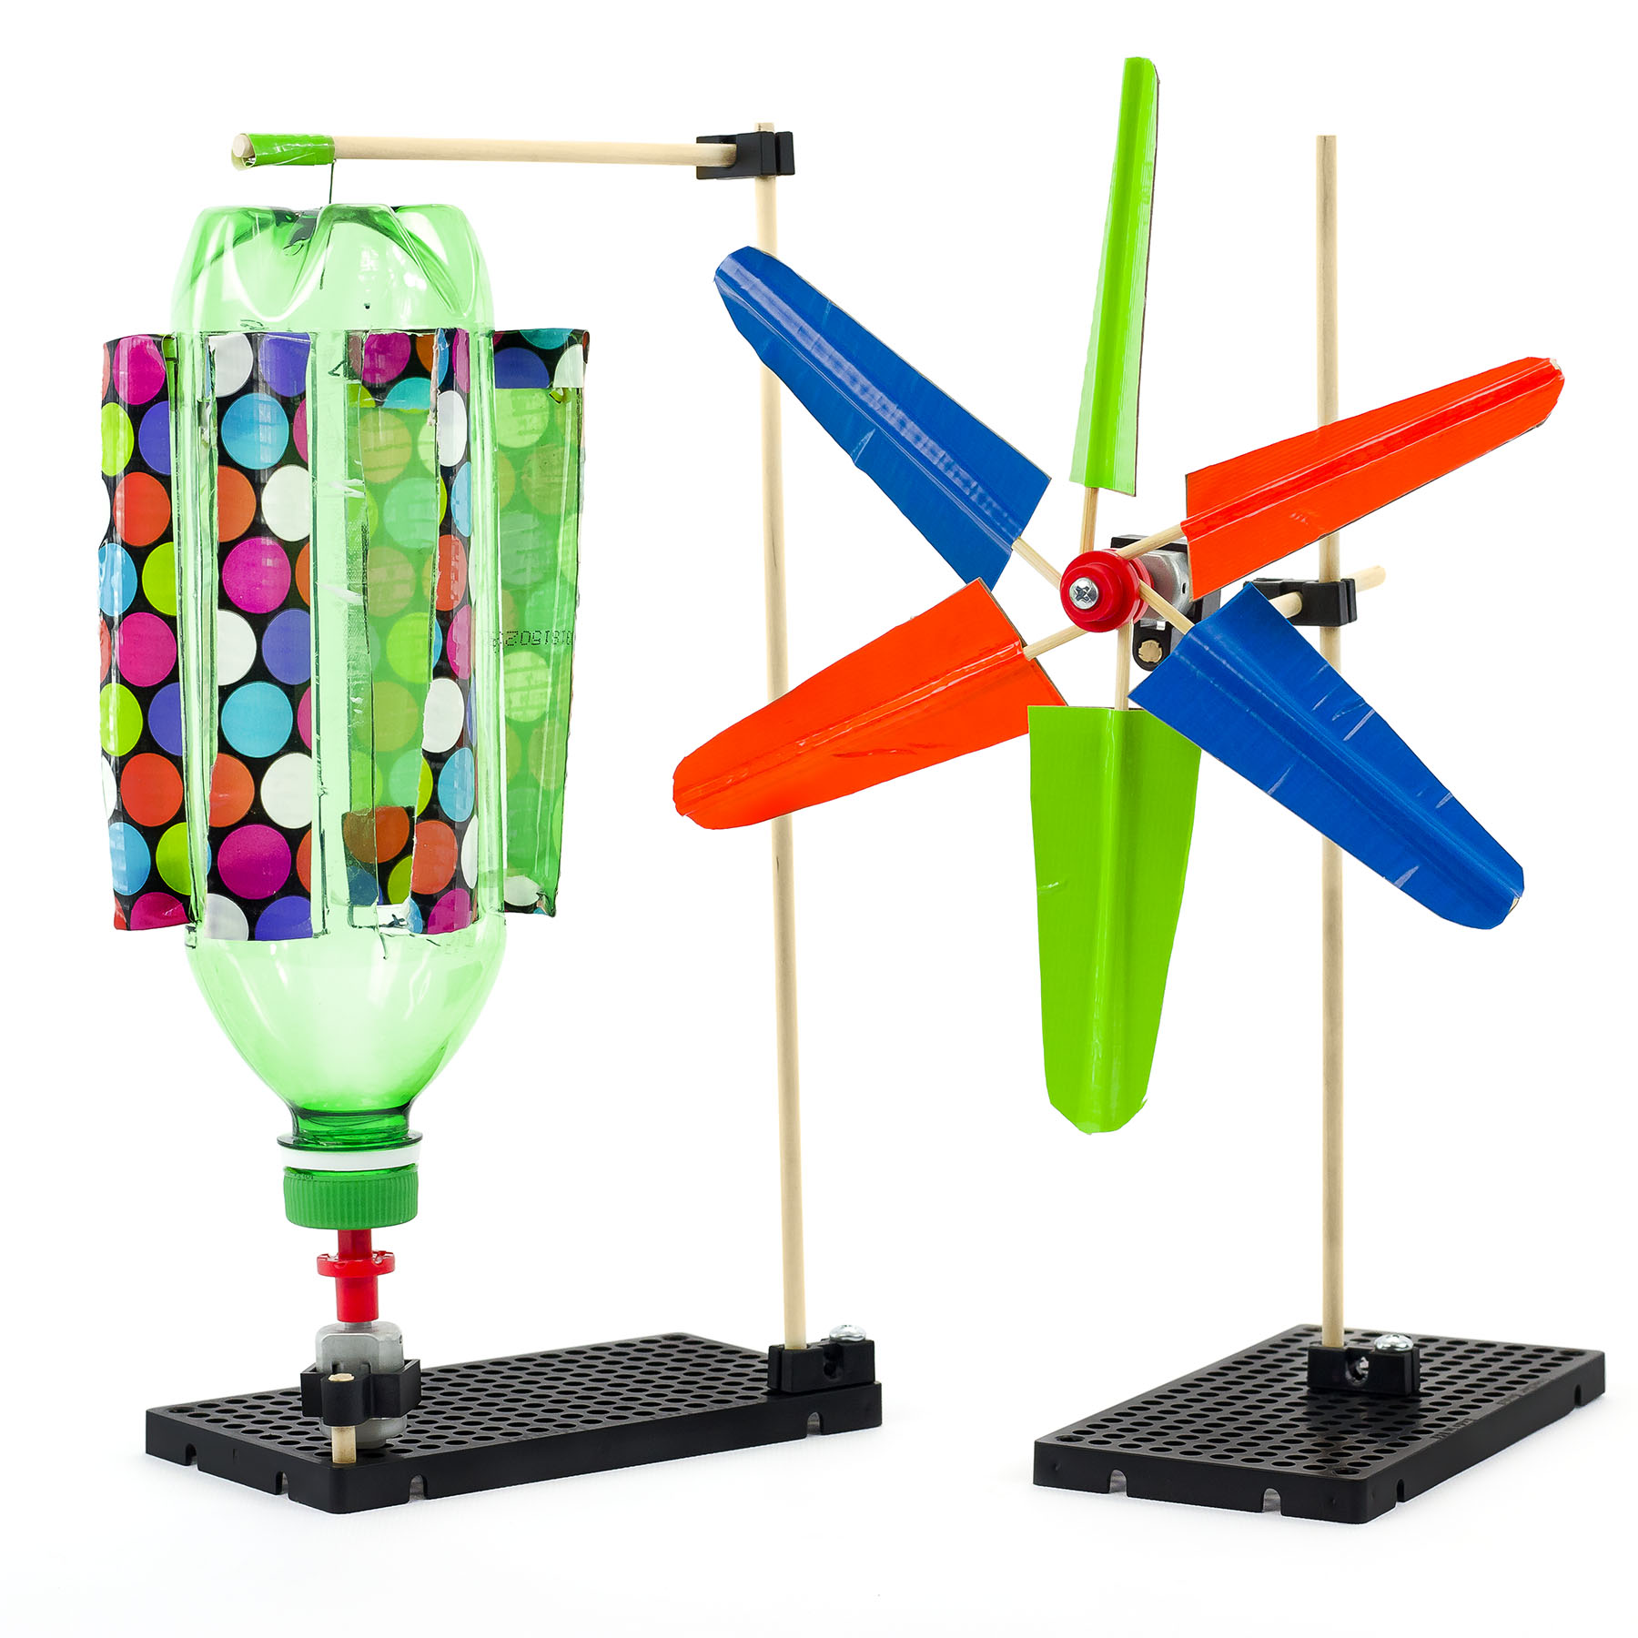This guide will help you create   
your own mini wind turbine.

  
**THINKING AHEAD** *What happens when you   
change the shape, size   
or type of blades?*

Download Documents at **teachergeek.com**



Below is the list of “ingredients” you’ll need for each mini wind turbine.  
Available as single: *SKU 1823-12* or 10 pack: *SKU 1823-13*. Both include extra parts for your own innovative creations!

|  |  |  |  |  |  |
| --- | --- | --- | --- | --- | --- |
| **x2** | **x2** | **x1** | **x1** | **x1** | **x1** |
| **Perpendicular Blocks** | 300mm (12″) **Dowels** | **Hole Plate** | ⅝″ or 1″ #10 **Screw** | ⅝″ #6 **Screw** | #10 **Nut**  **Double Check Your Supplies!** This activity needs motor mounts. |
| **x1** | **x1** | **x10** | **x1** | **x1** |  |
| **Mini Hub Cover** | **Mini Hub Base** | 150mm (10″) **Skewers** | 1.5V **Motor** | **Mini Motor Mount** |  |



*Perfect for sharing in groups of 3 and 4!*

Time to break out those tools and start building! Available at [demco.com](http://www.demco.com/goto?teachergeek)

|  |  |  |  |
| --- | --- | --- | --- |
|  |  |  |  |
| **Multi-Cutter** *SKU 1823-81* | **Screwdriver** *SKU 1823-90* | **Pliers** *SKU 1823-86* |  |



Go on your own scavenger hunt to find these items. Try creating with all kinds of things!

|  |  |  |  |
| --- | --- | --- | --- |
|  |  |  |  |
| **Tape** | **Recycling Materials** (for blades) | **Safety Goggles** |  |



|  |  |  |  |
| --- | --- | --- | --- |
|  | Attach one **perpendicular block** to the **hole plate** using a **#10 screws** and **#10 nuts**. |  | Push a **dowel** into the **perpendicular block** to create the turbine tower. |
|  | Cut a 100mm (4″) **dowel** and tap a **perpendicular block** onto the **dowel** as shown. |  | Push the **mini motor mount** onto the **dowel** from Step 3 and slide the **1.5V mini motor** into the **mini motor mount**. |
|  | Slide the **perpendicular block** onto the turbine tower **dowel**. |  | Attach the **mini hub cover** to the **mini hub base** using a **#6 screw**,  but keep the screw slightly loose.        **Quick Tip** *Hold the base with pliers when loosely turning in the screw.* |
|  | Press the **mini hub** onto the  **1.5V motor** shaft. |  | Yea! Your turbine stand is done! Time to make the rotor. |



It’s now time to experiment with blade designs. Change the shape, number (between 1 & 6), and the angle of the blades.

|  |  |  |  |
| --- | --- | --- | --- |
|  | Cut the points off the **skewers**.  *Note: you will only use three of the skewers to start. The others will be for your own design.* |  | Find materials for your **blades** like recycled materials, poster board, card board, plastic, etc.  You will also need **tape** (Duct Tape works best). |
| Design your **blades** and start by making 3 **blades** (below is one method).  Cut a section of **blade** material.  Place the **tape** half over the edge of the **blade** material. | | | |



Face sticky side up and place a **skewer**at the edge of the **blade** material, overhanging to one side.



Fold the **tape** over the **skewer** to secure to the **blade** material.

|  |  |
| --- | --- |
|  | Attach your **blades** to the **hub** by  loosening the **screw** (about a ¼ turn)  to allow the **skewer** to slide in.  3 or fewer **skewers** insert all the way into the **hub**.        **Blades** should be equally spaced in the **hub**.  *Remember:* Re-tighten the **screw** when **blades** are properly positioned.  6 **skewers** can be inserted as shown. |



1. How can you change the blade design to spin *faster*?
2. Would smaller blades increase power produced?
3. How would a different blade material or type work?

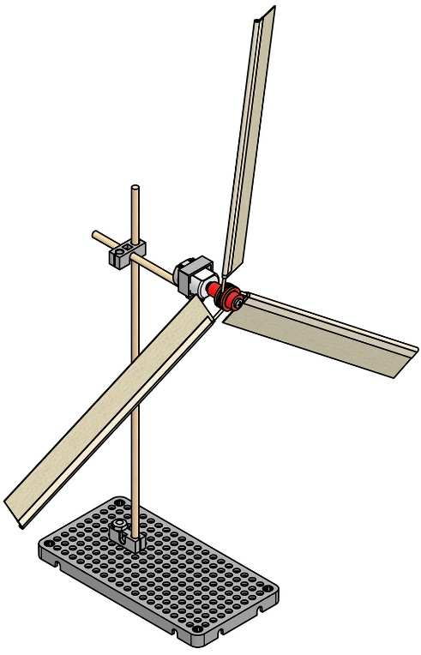

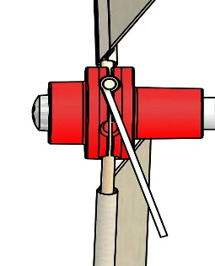a

**Congratulations!**  
Now try your design in the lab.

angle

Change your **blades** pitch when **screw**   
is loosened.